匈牙利Crescom Electra KFT有限公司
11.077MW/22.154MWh储能项目
Crescom Electra KFT .
11.077MW/22.154MWh Energy Storage Project

技术协议
Technical Agreement
Between
买方：匈牙利Crescom Electra KFT公司
Buyer: Crescom Electra KFT .
And
卖方：西安奇点能源股份有限公司
Seller: Xi’an JDEnergy Co., Ltd.
签订日期： ，Date of signing: .

Content
1. Overview 概述 4
1.1. Rights and Obligations of Buyer买方的权利和义务 4
1.2.Rights and Obligations of Seller卖方的权利和义务 6
1.3.Storage Requirements存储要求 6
2.Comply the Standard符合标准 8
3.System Design 系统设计 9
3.1 System Configuration 系统配置 9
3.2 System Equipment List (Supply Scope) 系统设备清单(供货范围) 11
4. Intelligent Energy Block eBlock-418A 智慧能量块eBlock-418A 13
4.1 General 通用 13
4.1.1 eBlock-418A Liquid Cooling 液冷 13
4.1.2 Product Specification产品规格 13
4.2 Lithium-ion Battery 锂离子电池 15
4.2.1 Battery cell 电池单体 15
4.2.2 Battery pack 电池PACK 16
4.2.3 Battery Rack 电池簇 16
4.3 Battery Management System 电池管理系统 17
4.3.1 BMS Functionality BMS 功能 17
4.4 Power Conversion System 储能变流器 18
4.4.1 Topology Diagram 拓扑图 18
4.4.2 Product Specification 产品规格 19
4.5 Auxiliary Equipment 辅助设备 20
4.5.1 Liquid Cooling System 液冷系统 20
4.5.2Fire Suppression System 消防系统 21
5. Intelligent energy eLink eLink418A智慧能量链eLink418A 23
6.Technical Documents and Drawings技术文件和图纸 26
6.1.General Requirements一般要求 26
6.2. Required Technical Documents and Drawings 要求的文件及图纸 26
6.3.Documents and Drawings to be Provided with the Shipment随运提供的文件和图纸 27
7.Miscellaneous其它事项 28

Abbreviations 缩写
JD Energy | Xi’an JDEnergy Co., Ltd奇点能源股份有限公司
AHJ | Authorities Having Jurisdiction 有管辖权的当局
BESS | Battery Energy Storage System 电池储能系统
BMS | Battery Management System 电池管理系统
BMU | Battery Management Unit 电池管理组
BCS | Block Control System 能量块控制系统
EMS | Energy Management System 能量管理系统
BOL | Beginning of Life起始寿命
ETH | Ethernet Module以太网模块
TMS | Thermal management system热管理系统
CAN | Controller Area Network控制器区域网络
DOD | Depth of Discharge 放电深度
FSS | Fire Suppression System灭火系统组件
PCS | Power Conversion System 储能变流器
SOC | State of Charge 荷电状态
SOE | State of Energy电池电量状态
SOP | State of Power功率状态
SOH | State of Health 电池健康度
POI | Point of Interconnection 互连点

1. Overview 概述
The purpose of this document is to define the supply scope of Seller for Battery Energy Storage System (BESS) projects and clarify the technical features of all equipment within the supply scope.
本文件旨在明确卖方对电池储能系统(BESS)项目的供货范围，明确供货范围内所有设备的技术特点。
In order to avoid any misunderstanding, matters not mentioned in this part should be determined by the parties to the contract through negotiation during the contract negotiation.
为避免任何误解，本部分未尽事宜，由合同签约双方在合同谈判时协商确定。
The seller guarantee to provide high-quality products and corresponding services that meet the requirements of industrial standards and this Technical Agreement, have complete functions and excellent performance, and meet mandatory national standards and specifications related to safety and environmental protection.
卖方保证提供符合工业标准和本技术协议书要求并且功能完整、性能优良的优质产品及其相应服务，同时满足与安全、环保等相关的强制性标准和规范。
Buyer understands and agrees that they are responsible for ensuring that the products which they have purchased from Seller meet the requirements of the applicable authorities having jurisdiction (“AHJ”) over the project. Seller takes no responsibility for ensuring that the products meet any AHJ requirements which are currently in effect, or which may be adopted by an AHJ in the future.
买方理解并同意，买方负责确保其从卖方购买的产品符合对项目有管辖权的当局(“AHJ”)的相关适用要求。卖方不负责确保产品符合AHJ目前有效的或未来可能被AHJ采用的任何要求。

Rights and Obligations of Buyer买方的权利和义务
1) Buyer shall ensure the safety of the Products provided and delivered by Seller,including taking corresponding measures against flood,fire,theft,pests,and sand/dust heavy environment. Without Seller prior written consent,Buyer shall never dissect or dismantle,dissemble or reverse-engineer any Product in whole or in part.
买方应确保卖方提供和交付的产品安全，包括采取应对洪水、火灾、盗窃、虫害和沙尘等环境的相应措施。未经卖方事先书面同意，买方不得对任何产品的全部或部分进行解剖、拆卸、拆解或改造。
2)Buyer shall promptly inform the personnel of Seller in case any abnormality is observed on the Product provided by Seller .Seller personnel shall present on site or support remotely to check the status of Product.
如果发现卖方提供的产品出现异常，买方应立即通知卖方人员。卖方人员应在现场或远程支持，以检查产品的状态。
3)Buyer shall ensure that the BESS will not run in any severe environment with high temperature,high heat,radiation,impact or immersion.
买方应确保BESS不会在任何高温、高热、辐射、冲击或浸泡的恶劣环境中运行。
- Seller provides training and support to Buyer .
卖方为买方提供培训和支持。
5) Buyer shall be responsible for the unloading of delivered BESS, provide a site for the storage of BESS and have them in its custody.In addition.Buyer shall protect the delivered BESS from damage, loss, deformation, dampness and corrosion.
买方应负责卸载交付的BESS，为BESS提供储存场所，并将其保管。此外买方应保护交付的BESS免受损坏、丢失、变形、潮湿和腐蚀。
6)Buyer shall assist the personnel of Seller on site,provide or assist with required accommodation, sustenance, transportation and communication, and the access rights to this project to provide technical support for installation and commission. Where the Product of Seller is delivered to the place specified by Buyer,Buyer shall be responsible for the custody of the Product after delivery, Seller shall not be responsible for any loss or damage attributable to Buyer.
买方应在现场协助卖方人员，提供或协助提供所需的住宿、食物、运输和通信，以及进入项目现场的许可。当卖方的产品交付到买方指定的地点后，买方负责对产品进行保管。卖方不对买方造成的任何损失或损害负责。
7)Buyer shall not carry out and be solely responsible for any operation related to overcharging, over-discharging, abuse, short-circuiting that may cause damage to the battery.
买方不得进行任何与过度充电、过度放电、滥用、短路有关的操作，这些测试可能会对电池造成损坏，如有违反，买方将承担全部责任。
- Buyer shall be responsible to provide the auxiliary power 400Vac 50/60Hz for this BESS project on project site.
买方需在该项目现场为此储能项目提供400V 50/60Hz辅助电源。

1.2.Rights and Obligations of Seller卖方的权利和义务
1)Seller shall provide Buyer with reliable Products, commissioning and related technical support confirmed by both parties.
卖方应向买方提供可靠的产品，以及双方确认的调试和相关技术支持。
2)The Products provided by Seller to Buyer shall meet the parameter requirements stipulated in this Agreement.
卖方向买方提供的产品应符合本协议规定的参数要求。
3)Seller shall provide the necessary technical services for the Product.The technical service shall contain technical support of installation ,commission and training.
卖方应为产品提供必要的技术服务。服务包括安装、调试技术支持及培训。
4)After the technical specification is mutually agreed, Seller shall not make any change to the technical specification without the written consent of Buyer.For any change in the design parameters or other important technical parameters , Seller shall inform Buyer in advance and obtain the prior written consent of Buyer.
双方同意技术规范后，未经买方书面同意，卖方不得对技术规范进行任何更改。对于设计参数或其他重要技术参数的任何变更，卖方应提前通知买方，并事先获得买方的书面同意。
5)Seller shall provide the information related to its Product at the reasonable request of Buyer.
卖方应在买方的合理要求下提供与其产品相关的信息。

1.3.Storage Requirements存储要求
- Buyer shall ensure that the BESS is stored in environment where the average temperature<25℃,humidity<95%.If there is a conflict of storage environment temperature range requirement between the warranty agreement and this agreement,the warranty agreement shall prevail.However it will accelerate the degradation of BESS capacity if the storage condition ≥25℃.
买方应确保BESS储存在平均温度<25℃、湿度<95%的环境中。如果保修协议与本协议的存储环境温度范围要求不一致，以保修协议为准。但是，如果储存条件≥25℃，将会加速储能系统容量的衰减。
2)If the period between shipment date from factory of Seller and the completion date of installation & commission exceeds 3 months,the capacity of BESS shall be reduced .In this case,the initial degradation corresponds to the irreversible degradation reflecting the period, So the device should be operated as soon as possible within 3 months after the shipment from factory of Seller .
如果工厂发货日期和现场安装调试日期之间的时间超过3个月，储能系统容量将会减少。在这种情况下，初始衰减为不可逆衰减，所以储能系统应该在工厂发货后三个月内尽快运行设备。

2.Comply the Standard符合标准
国家  Country | 规范  Regulation | 标准  Standard | 备注  Marks
Hungary | Safety for eBlock | EN 62477-1:2012/A12:2021  IEC 62477-1:2012 | Safety Regulation for PCS and ESS
Hungary | Safety for eLink | EN 62477-1:2012/A12:2021  IEC 62477-1:2012  IEC 60204-1 | Safety Regulation for Electric and Communication Cabinet
Hungary | EMC | EN 55011:2016/A1:2021 | EMC
Hungary | EMC | EN IEC 61000-6-2:2019 | EMC
Hungary | EMC | EN IEC 61000-6-4:2019 | EMC
Hungary | Grid code | RFG+EN50549-2 with national of Hungary | Hungary Grid Code
Hungary | Grid code | VDE 4110 & VDE 4120 | Hungary Grid Code
Hungary | Safety for Batteries | IEC 62619 | Safety Regulation for Battery
Hungary | Safety for Batteries | IEC 63056 | Safety Regulation for Battery
Hungary | Safety for Batteries | IEC 60730-1 ANNEX H | Safety Regulation for Battery
Hungary | eBlock | UN38.3

3.System Design 系统设计

3.1 System Configuration 系统配置
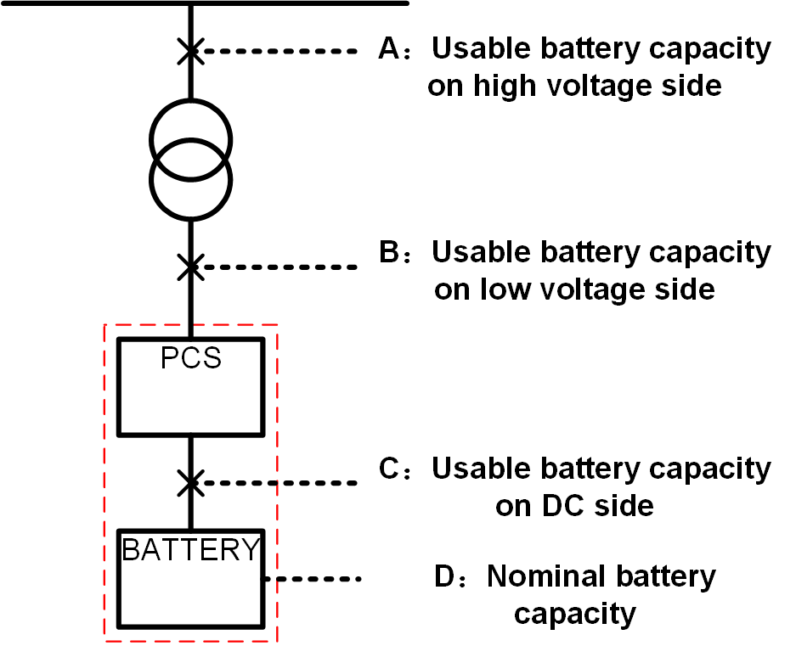
The nominal battery capacity of the DC side （D point） in the project is 11.077MW/22.154MWh. The whole scheme consists of 53 energy blocks eBlock-418A and 4 sets of energy chains eLink418A. Because of the degradation characteristics of the battery, the capacity of the energy storage system will degrade by time. The working condition will not more than 660 cycles per year(not more than 2 cycles per day),not more than 0.5 C-rate charging and discharging.
The eBlock-418A energy block has a capacity of 209kW/418kWh, and its main configurations include: PCS with a rated power of 215kW, 418kWh battery system (DC voltage 1165-1498V), 1 set of battery management system (BMS), communication management system, liquid cooling system, and Fire Suppression System.
The eBlock-418A energy block adopts a modular unit design with an AC output of 690V. Direct AC side parallel expansion is possible. Each energy block has the same appearance and style. The modular design reduces the risk of product failure, and the capacity can be flexibly configured. Adopting outdoor design with a protection level of IP55, it only can be installed outdoors.
The Intelligent energy eLink eLink418A is a link unit for the energy flow and data flow of the energy storage system, including 1 sets of the power cabinet eLink418A-16P and 1 set of the communication cabinet eLink418A-16C, which supports up to 16 eBlock-418 energy blocks to be used simultaneously.
本项目直流侧标称容量（D点）为11.077MW/22.154MWh，整个方案有 53 个 能量块eBlock-418A，4套能量链eLink418A组成。因为电池衰减特性，储能系统容量会逐年降低。工况条件每年不超过 660次循环(每天不超过2个循环)，不大于0.5C充放电倍率。
eBlock-418A能量块容量为209kW/418kWh，其主要配置有：1套额定功率215kW的PCS、1套418kWh蓄电池系统（直流电压1165-1498V）、1套蓄电池管理系统（BMS）、1套通讯管理系统、1套热管理系统和1套消防系统。
eBlock-418A能量块采用模块单元式设计，交流690V输出，可直接交流侧并联扩容。各能量块外观一致、风格统一，模块化设计降低产品故障带来的风险，可灵活配置容量。采用户外设计，防护等级IP55，仅能安装在户外。
智慧能量链eLink418A是储能系统能量流和数据流的链接单元，包括1台功率柜eLink418A-16P和1台通信柜eLink418A-16C，支持最多16台eBlock-418A能量块并机使用。

3.2 System Equipment List (Supply Scope) 系统设备清单(供货范围)
系统设备清单
System Equipment List
No.  序号 | Item  设备项 | Specification  型号 | Qty  数量 | Unit  单元 | Remark  备注
1 | Intelligent  Energy Block  智慧能量块 | eBlock-418A | 53 | pcs | -Each Block consists of 1.1 ~1.4.  -Using a 3.2V 314Ah LFP battery cell.  -Continuous discharge rate 0.5P.  -Capacity is 417.997kWh.  -Dimension（W*D*H）：1400mm×1300mm×2350mm  -Composed of 1 battery rack 1P416S.  -Each battery Rack consists of 8 battery Packs.  -每个Block 由 1.1 ~1.4 个组成。  -采用3.2V 314Ah磷酸铁锂电芯。  -持续放电倍率0.5P。  -容量为417.997kWh。  -（W*D*H）：1400mm×1300mm×2350mm  -由1个电池簇组成，组成方式1P416S。  -每个电池簇由8个电池组组成。
1.1 | PCS  储能变流器 | PCS-2000G2 | 53 | pcs | -Rated power 215kW.  -Protect level IP65 rating.  -AC output 690V/50Hz.  -DC input range 1165-1498V.  -额定功率215kW。  -防护等级IP65。  -交流输出690V/50Hz。  -直流输入范围1165-1498V。
1.2 | Battery Pack  电池PACK | eBlock418A-PACK | 424 | pcs | - Each eBlock consists of 8 battery packs  - 每个eBlock由8个电池PACK组成。
1.3 | BCS Control Software  电池管理系统控制软件 | Battery management and control system software v1.0 | 53 | pcs
1.4 | Thermal Management System  热管理系统 | Liquid cooling | 53 | pcs | - Rated refrigeration power 8kW.  - 额定制冷功率8kW。
2 | Intelligent  Energy Link  智慧能量链 | eLink418A | 4 | Set | -Each Block consists of 2.1 ~2.3.  -Integrated auxiliary power distribution system, including bus bars, and coordination controllers. Including Large-scale Energy Storage Power Station Centralized Control Software v1.0.  -每个eLink 由2.1 ~2.3 个组成。  -集成辅助配电功能，含汇流母排和协调控制器等设备。包括大型储能电站集群控制软件v1.0。
2.1 | Power Energy Link  功率柜 | eLink418A--16P | 4 | pcs | - Energy convergence of the eBlocks.  -能量汇流。
2.2 | Communication Energy Link  通信柜 | eLink418A--16C | 4 | pcs | - Data convergence of the eBlocks.  -数据汇流。
2.3 | Rack Control Software  电池簇控制软件 | Large-scale energy storage power station rack control software V1.0 | 4 |  | - Large-scale Energy Storage Power Station Rack Control Software v1.0..  -大型储能电站集群控制软件v1.0。
3 | Cables and Accessories  电缆及附件 |  | 4 | set | - From eLink to eBlock power cable, communication cable and accessories.  -eLink到eBlock的功率电缆、通信电缆及配件。

NOTES:
- Transformers and EMS are not including, and will provided by Buyer.
- The Cable is not including from eLink to the transformer, and will provided by Buyer.
注:
- 不包含变压器和EMS，由买方提供。
- 不包含eLink至升压变压器间的电缆，由买方提供。

4. Intelligent Energy Block eBlock-418A 智慧能量块eBlock-418A

4.1 General 通用

4.1.1 eBlock-418A Liquid Cooling 液冷
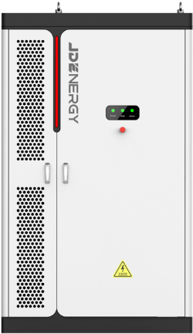
Appearance diagram of eBlock-418A (Reference only)
eBlock-418A 外观图(仅供参考)

4.1.2 Product Specification产品规格
Technical Parameters of eBlock-418A
eBlock-418A技术参数
Type Designation  类型名称 | eBlock-418A
System data 系统数据
Cell type 电芯类型 | LFP 314Ah
Battery capacity (BOL) 电池容量(BOL) | 418 kWh
Battery voltage range 电池电压范围 | 1164.8~1497.6V
Number of temperature monitoring温度监测数目 | 224
DC Component 直流分量 | <0.5%lpn
Operation temperature 充放电倍率 | ≤0.5P
Maximum Allowable Depth Of Discharge 最大允许放电深度 | 100% DOD
Battery Cell Number of cycles 电芯循环次数 | 7000
Thermal management method 热管理方式 | Air cooled（PCS）+Liquid cooled(battery)
General Data通用数据
Dimensions of battery unit (W * H * D)  电池单元尺寸(宽 * 高 * 深) | 1400*2350*1300mm
Operating temperature range 工作温度范围 | -35~55℃ (>40℃ derating降额)
Relative humidity 相对湿度 | 0 ~ 95% (non-condensing无凝露)
Max. working altitude 最大工作高度 | ≤2000m
Degree of protection防护等级 | IP55
Noise 噪音 | ＜80dB
Net Weight净重 | 3800Kg
Fire safety 消防安全 | Aerosol+Reserve water fire interface
Communication interfaces 通信接口 | LAN
Equipment enclosure color设备外壳体颜色 | RAL9003
Equipment enclosure logo设备外壳体丝印 | Provided by customer 由客户提供

4.2 Lithium-ion Battery 锂离子电池

4.2.1 Battery cell 电池单体
Specification of Battery cell
电池单体规格
Sample 示样图 | Item 项 | Specification 参数
  (For reference only) | Type of Battery  电池类型 | LFP 314Ah
 | Nominal voltage  标称电压 | 3.2V
 | Nominal Capacity  标称能量 | 1004.8Wh
 | Nominal voltage  额定电压 | 3.2V
 | Nominal charge/discharge rate  标称充/放电倍率 | 0.5P
 | Internal resistance  内阻 | 0.18±0.05mΩ  Fresh cell （~30%SOC）
 | Number of cycles  循环次数 | 7000
 | Operation temperature  工作温度 | 0~60℃ Charging  -20~60℃ Discharging
 | Storage temperature  储存温度 | -35~60℃  Storage ambient humidity < 85% ROH, no condensation
 | Dimension (W×H×D) (mm)  尺寸 | 174.26±0.8*204.44±0.8*71.55±0.8
 | Weight (kg)  重量 | 5.56kg±0.3kg

4.2.2 Battery pack 电池PACK
Specification of Battery Pack
电池PACK规格
Sample 示样图 | Item 项目 | Specification 参数
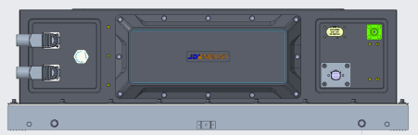  (For reference only) | Type of Battery 电池类型 | LFP 314Ah
 | Configuration 配置 | 1P52S
 | Nominal Capacity标称容量 | 52.25kWh
 | Nominal Voltage 标称电压 | DC 166.4V
 | Operating Voltage工作电压 | 145.6V～187.2V
 | Dimension (W×D×H) (mm) 尺寸 | 810±3*1050±3*241±3
 | Weight 重量 | ≤ 350 kg

4.2.3 Battery Rack 电池簇
The battery Rack adopts a frame structure, and the battery Pack is fixed by bolts.
The battery Rack consists of 8 battery Packs. The battery Packs are arranged in the energy storage cabinet from top to bottom and connected through dedicated connectors on the front panel. The nominal voltage is 1331.2V.
电池簇采用框架式结构，电池Pack通过螺栓固定。
电池簇包括8个电池Pack，电池Pack从上到下依次布置于储能柜，通过前面板的专用连接器连接。标称电压为1331.2V。

Specification of Battery Rack
电池架规格
Sample | Item 项 | Specification  参数
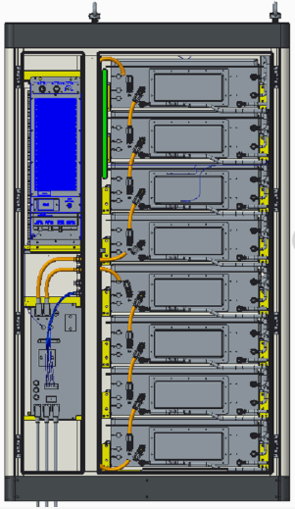  (For reference only) | Type of Battery 电池类型 | LFP 314Ah
 | Configuration 配置 | 1P416S
 | Key Components 关键部件 | 8 Packs
 | Nominal Capacity 标称容量 | 417.996kWh
 | Nominal Charge/Discharge Rate  标称充/放电倍率 | 0.5P
 | Nominal Voltage  标称电压 | DC 1331.2V
 | Operating Voltage Range  工作电压范围 | 1164.8~1497.6V

4.3 Battery Management System 电池管理系统

4.3.1 BMS Functionality BMS 功能
The BMS system of eBlock-418A energy block adopts battery and converter collaborative control technology.
Each battery module management unit BMU collects the voltage, temperature, and gas parameters of the battery cells inside the battery pack and communicates with the BCS (Battery&Converter Collaborative Control Unit).
BCS combines other collected data (including environmental temperature, cabinet temperature, battery status, and other series of parameters) with scheduling instructions to take balancing measures on the battery and control the power of the converter PCS.
eBlock-418A能量块的BMS系统采用电池&变流器协同控制技术。
每个电池模块管理单元BMU采集电池Pack内电芯电压、温度以及可析出气体参数至BCS（电池&变流器协同控制单元）。
BCS结合采集的其他数据（包括环境温度、柜内温度、电池状态等系列参数）以及调度指令，对电池采取均衡措施以及对变流器PCS进行功率控制。
Architecture diagram of BMS
电池管理系统架构图
BMS can be integrated with PCS for design, greatly reducing the possibility of protection unit action timing, action delay, and local fault protection failure within the energy storage system, and designing graded actions and linkage mechanisms for protection.
BMS与PCS融合设计，大幅减少储能系统内保护单元动作时序、动作延时以及局部故障保护失效的可能性，设计保护的分级动作和联动机制。

4.4 Power Conversion System 储能变流器

4.4.1 Topology Diagram 拓扑图
Topology diagram of PCS-2000G2
PCS-2000G2的拓扑图
The PCS device can automatically synchronize with the power grid, and it has a primary frequency regulation function.
At any stage of charging and discharging, necessary current limiting measures should be taken according to the needs of the battery to avoid damage to the battery.
PCS装置能自动与电网同步，PCS装置具备一次调频功能。
充电和放电任何阶段都根据电池的需要采取必要的限流措施，避免对电池造成损害。

4.4.2 Product Specification 产品规格
Technical Parameters of PCS-2000G2
PCS-2000G2 技术参数
Type Designation  类型名称 | PCS-2000G2
DC side 直流侧
Max. DC voltage 最大直流电压 | 1500 V
Min. DC voltage 最小直流电压 | 1026V
DC voltage range 直流电压范围 | 1026– 1500 V
Max. DC current 最大直流电流 | 209.5A
Max. DC power 直流最大功率 | 241kW
AC side (Grid mode) 交流测
AC output power AC 输出功率 | 215kW (Reduce to 209kW)
AC Max. power AC最大功率 | 241kW
AC rated current AC额定电流 | 180A
Rated grid voltage 额定电网电压 | 690V±15%
Rated grid frequency 额定电网频率 | 50/60 Hz
AC voltage distortion rate 交流电压畸变率 | < 3 %
Adjustable power factor 功率因数调节范围 | -1 ~1
Charge and discharge switching time  充放电切换时间 | ＜100ms
Efficiency 效率
System Max. efficiency 储能变流器最大效率 | 98.5% discharge Charging  98.5% charge Discharging
General Data 通用数据
Degree of protection 防护等级 | IP65
Interface 通讯接口 | LAN
Cooling method 冷却方式 | forced air cooling
Operation temperature 工作温度 | -40 to 60 ℃
Relative humidity 相对湿度 | 0 - 95 %
Altitude 海拔 | ≤2000m
Dimensions (W*H*D)（mm） 尺寸 | 630*250*1050
Weight 重量 | ＜130kg
Noise 噪音 | ＜80dB

4.5 Auxiliary Equipment 辅助设备

4.5.1 Liquid Cooling System 液冷系统
The system uses a liquid cooling system for heat dissipation.
Liquid cooling is a technology that uses liquid as a refrigerant to remove heat from cells. It has excellent temperature homogeneity and low power consumption. The liquid cooling system mainly consists of pipes, pumps, heat ex-changer and compressors. The coolant of the system is ethylene glycol liquid.
系统采用液冷散热方式。
液冷是一种利用液体作为制冷剂，从电池中去除热量的技术。它具有优异的温度均匀性和低功耗。液冷系统主要由管道、泵、热交换器和压缩机组成。该系统的冷却剂为乙二醇水溶液。
Each eBlock-418A contains a total of 8 sets of battery packs with parallel water circuits. Each pack is equipped with independent water-cooled channels and corresponding inlet and outlet ports. The coolant in the chiller unit enters the water-cooled channels of each pack through parallel connection driven by a water pump, absorbing heat and dissipation generated inside the pack. The absorbed coolant is then collected again and flows into the chiller unit.
每个eBlock-418A内共包含有 8 组水路并联的电池 Pack，每组 Pack 设有独立的水冷流道及相应进出口，冷水机组内的冷却液在水泵的驱动下通过并联的方式进入到每个Pack的水冷流道内，吸收 Pack 内部产生的耗散热，吸热后的冷却液再次汇集并流入到冷水机组内。
Operating principle 工作原理
The coolant is pumped to the battery. After absorbing the heat generated by the battery it is returned to the Water Chiller.
冷却剂被泵送到电池中。在吸收了电池产生的热量后，冷却剂被送回冷水机组。
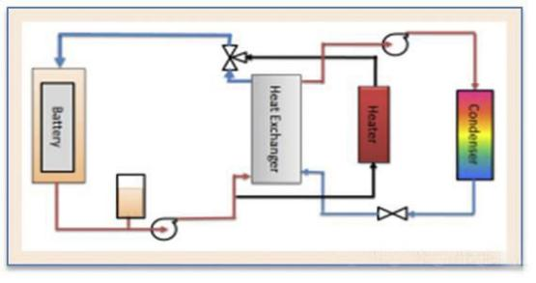
Operating principle
工作原理

4.5.2Fire Suppression System 消防系统
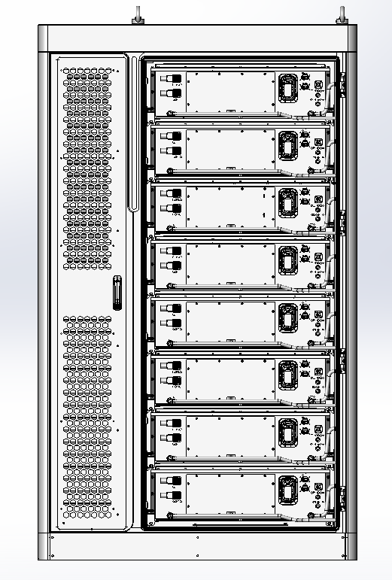
Battery cabinet diagram
电池柜示意图
Each battery pack is a monitoring unit, and each battery pack is equipped with a monitoring module to realize the monitoring and alarm of the battery pack level. The energy storage cabinet is equipped with temperature sensors, smoke detectors, combustible gas detectors, and an aerosol protection device. Additionally, the energy storage cabinet reserves a water fire protection interface. The buyer decides for themselves whether to design and use the on-site water fire protection pipeline. .
每个电池包为一个监控单元，每个电池包都配有监测模块，实现对电池包级的监测和报警。储能柜内配有温感、烟感、可燃气体探测器，并配有气溶胶保护装置，另外储能柜预留水消防接口，买方自行决定是否设计并运用现场水消防管路。

5. Intelligent energy eLink eLink418A智慧能量链eLink418A
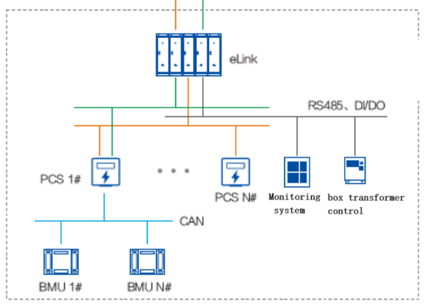
eLink communication network diagram
eLink通讯网络图
智慧能量链eLink418A是储能系统能量流和数据流的链接单元，包括1台功率柜eLink418A-16P和1台通信柜eLink418A-16C，支持最多16台eBlock-418A能量块并机使用。
The intelligent energy eLink eLink418A is a link unit for the energy flow and data flow of the energy storage system, including 1 sets of the power cabinet eLink418A-16P and 1 set of the communication cabinet eLink418A-16C, which supports up to 16 eBlock-418 energy blocks to be used simultaneously.
eLink418A-16P功率柜是储能系统能量流的链接单元，集成开关器件。采用标准化部件，单柜满足16台eBlock-418A能量块并机使用。向下连接能量块，向上连接变压器低压侧，完成输出交流电力的汇流，实现能量流的双向链接和管理。
eLink418A-16P power distribution cabinet is a link unit of energy flow of the energy storage system, integrating switching devices. Using standardized components, a single cabinet can meet 16 eBlock-418A energy blocks for parallel use. The energy block is connected downward and the low voltage side of the transformer is connected upward to complete the confluence of the output AC power, and two-way link and management of the energy flow.
eLink418A-16P parameters
能量链eLink418A-16P参数表
序号NO | 项目  Item | 系统参数  Parameter
1 | 产品型号Product model | eLink418A-16
2 | 系统电压System voltage | AC 690V
3 | 额定功率Rated power | 3344kW
4 | 额定电流Rated current | 2798A
5 | 短路保护Short circuit protection | Possess
6 | 接入路数Number of access channels | ≤16
7 | 输出路数Number of access channels | 1
8 | 工作温度Operating temperature | -35~55℃ (>40℃ reduce power)
9 | 相对湿度Relative humidity | 0%RH ～ 95%RH，non-condensing
10 | 系统防护等级System protection grade | IP55
11 | 海拔高度Altitude | ≤2000m
12 | 噪音Noise | < 80dB
13 | 尺寸（宽*高*深）  Dimensions (W * H * D)（mm） | 1000×1300×2350

eLink418A-16C通信柜是储能系统数据流的链接单元，作为能量块和能量管理系统EMS的连接桥梁，实现本地和站端数据的高速通信连接，并为能量管理系统提供可靠的数据采集、存储和控制管理平台。
eLink418A-16C communication cabinet is the link unit of the data flow of the energy storage system, as the connection bridge between the energy block and the energy management system EMS, to realize the high-speed communication connection of local and station data, and to provide a reliable data acquisition, storage and control management platform for the energy management system. Provide graded power supply and power metering for the entire array of stations .
eLink418A-16C parameters
能量链eLink418A-16C通信柜参数表
序号NO | 项目  Item | 系统参数  Parameter
1 | 产品型号Product model | eLink418A-16C
2 | 接入路数Number of access channels | ≤16
3 | 输出路数Number of access channels | 1
4 | 通讯接口Communication interface | Ethernet
5 | 通讯协议Communication protocol | IEC104，IEC61850，Modbus（TCP，RTU）
6 | 工作温度Operating temperature | -20℃ ～ 55℃（40℃ Reduce power）
7 | 相对湿度Relative humidity | 0%RH ～ 95%RH，non-condensing
8 | 系统防护等级  System protection grade | IP55
9 | 海拔高度Altitude | ≤2000m
10 | 噪音Noise | < 50dB
11 | 尺寸（宽*高*深）（mm）  Dimensions (width * height * depth) | 1000×1300×2350

6.Technical Documents and Drawings技术文件和图纸

6.1.General Requirements一般要求
Documentation should be well-organized with a strong logical structure. The content of the documentation must be correct, accurate, consistent, clear, and complete, meeting the engineering requirements.
文件结构清晰、逻辑性强。文件内容正确、准确、一致、清晰完整，满足工程要求。

6.2. Required Technical Documents and Drawings 要求的文件及图纸
Scope list of documents
文件范围清单
No. | Document name文件名称 | Specification规格 | Delivery Schedule交货时间表
1 | Equipment Layout Drawing  设备布置图 | Electronic files  电子文件 | Provided before the Product arrival a site在产品到达现场之前提供
2 | Foundation Drawing  基础图 | Electronic files  电子文件 | Provided before the Product arrival a site在产品到达现场之前提供
3 | Communication protocols  通信协议 | Electronic files  电子文件 | Standard protocols to be provided within two weeks after the signing of the this Agreement.  标准协议将在本协议签署后两周内提供。
4 | Factory Testing  工厂测试报告 | Electronic files  电子文件 | Provided together with the Product  与产品一起提供

6.3.Documents and Drawings to be Provided with the Shipment随运提供的文件和图纸
Scope list of documents
文件范围清单
No. | Document name文件名称 | Specification规格 | Delivery Schedule交货时间表
1 | User Manual  用户手册 | Paper files Or Electronic files纸质文件或电子文件 | Provided together with the Product  与产品一起提供
2 | Equipment List  设备清单 | Paper files Or Electronic files纸质文件或电子文件 | Provided together with the Product  与产品一起提供
3 | Installation Manual  安装手册 | Paper files Or Electronic files纸质文件或电子文件 | Provided together with the Product  与产品一起提供
4 | Type Test Report  型式试验报告 | Paper files Or Electronic files纸质文件或电子文件 | Provided together with the Product  与产品一起提供
5 | Manufacturer's Warranty Card  制造商的保修卡 | Paper files Or Electronic files纸质文件或电子文件 | Provided together with the Product  与产品一起提供

7.Miscellaneous其它事项
1) This Agreement shall enter into force upon the signature by both parties.
本协议自双方签字之日起生效。
2) The provision of confidentiality requirement sand intellectual property rights as set forth in the Main Contract or non-disclosure agreement shall apply to this Agreement.
主合同或保密协议中规定的保密要求和知识产权适用于本协议。
3)This Agreement is an integral part of the Main Contract.Any matter that is not covered herein shall be subject to the Main Contract.In the event of any conflict between the Main Contract and this Agreement, this Agreement shall prevail.
本协议是主合同不可分割的组成部分。本合同未尽事宜以主合同为准。如果主合同与本协议有任何冲突，以本合同为准。

.........................(Buyer Company Name买方公司名称)
Signature签名:
Name名字:

.........................(Seller Company Name卖方公司名称)
Signature签名:
Name名字:

