eBlock-100C-CE
Product Specification
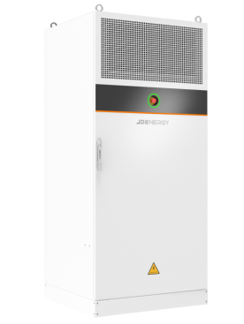

Contents

1 Product Specification 4
1.1 eBlock-100C-CE 4
1.2 Product Data 5
1.3 Advantage 8
1.4 System operating mode 10
① Self-use 10
② Economic model 11
③ Backup mode 12
2 Battery Cell 13
3 Pack 15
4 RACK 16
5 Battery Management System(BMS) 17
7 PCS 18
8 Liquid Cooling System 22
9 Fire Suppression System 24

1 Product Specification

1.1 eBlock-100C-CE
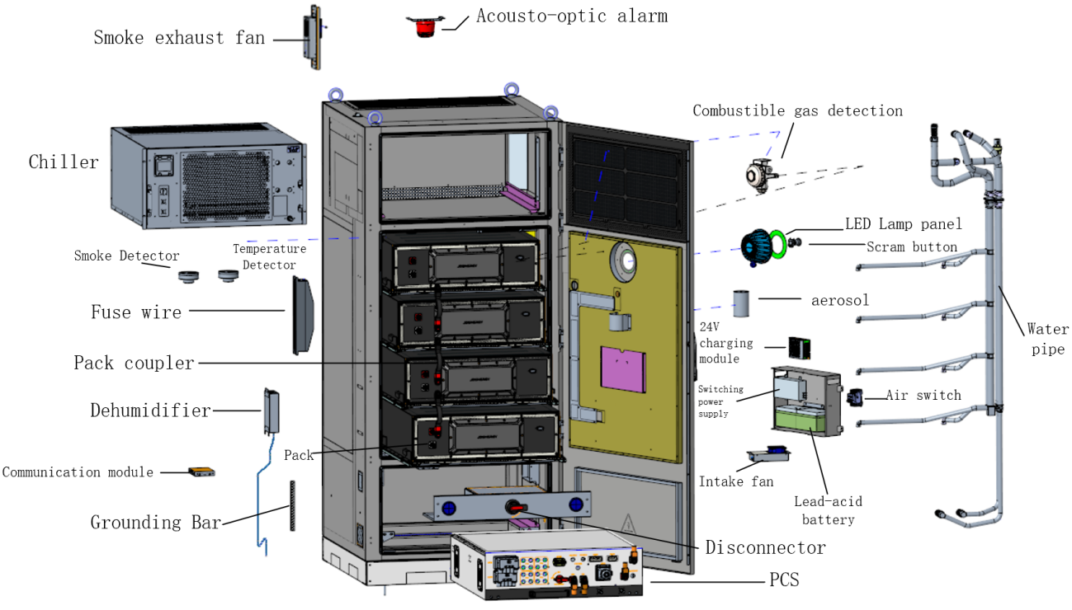
eBlock-100C-CE integrated PV inverter, energy storage device, it mainly consists of a liquid-cooling hybrid inverter, liquid-cooling battery PACK, a liquid-cooling thermal management chiller and so on. Its design complies with the IEC standards and is mainly applied in scenarios where there is a demand for newly built industrial and commercial photovoltaic energy storage charging stations. The whole device integrates photovoltaic MPPT, battery DC/DC, and DC/AC bidirectional conversion. It can provide on-grid and off-grid functions externally and meet different application scenarios on the customer's site. It offers different EMS (Energy Management System) modes such as self-consumption, economic mode, and backup power mode. The main application scenarios include shopping malls, office buildings, hotels, commercial complexes, factories, distributed photovoltaic power generation, energy storage for distribution substations, zero-carbon parks, microgrids.

1.2 Product Data
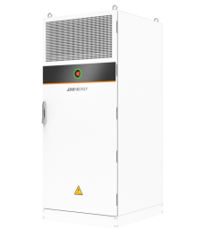
eBlock-100C-CE Technical specifications

PV Data
Maximum PV Input Power | 100kWp
Maximum DC Input Voltage | 1000V
Rated DC Bus Bar Voltage | 720V
MPPT Voltage Range | 150-900V
PV Function | DC switch
Battery Data
Rated Capacity | 120kWh
DOD | 100%
Grid Input Data
Rated Voltage | 400V（-15%~10%）3L/N/PE
Maximum Input Power | 100kVA
Rated Frequency | 50Hz
Maximum Input Current | 144.4A
Output Data On-Grid
Rate Output Power | 50kVA
Maximum Output Power | 55kVA/long-term；
Power Factor | -0.8~0.8
Rated Output Voltage | 400V（-15%~10%）3L/N/PE
Rated Frequency | 50Hz
Rated Output Current | 72.2A
Maximum Output Current | 79.4A
Output Data Off-Grid
Rate Output Power | 50kVA
Maximum Output Power | 55kVA/long-term；55kVA~60kVA/1 min；
Power Factor | -0.8~0.8
Rated Output Voltage | 400V（-15%~10%）3L/N/PE
Rated Frequency | 50Hz
Rated Output Current | 72.2A
Maximum Output Current | 79.4A
System Data
Maximum Number Of Parallel Devices Supported | 4（Need to use combiner cabinet）
Temperature Range | ﹣35℃~45℃（45℃-60℃ Derate）
Humidity Range | ≤95%，No condensation
Main Fire Protection | Aerosol
Standby Fire Protection | Reserved Water Fire Port
Response Time | ＜50ms
Charge and Discharge Switching Time | ＜50ms
Thermal Management | Liquid Cooling （PCS+PACK）
Pressure Relief Mode | Explosion valves
Anticorrosion Grade | C5
Protection Level | IP55(Battery cluster）
Cable Connection Mode | In and Out From the Bottom
Cable Joint | AC push-in fittings
Equipment Foundation | No Need Excavation，（Support pre-embedded wire base）
Altitude | ≤2000m
Emergency Shutdown | Comply
Dimension(W*D*H) | 1000mm*1000mm*2270mm
Weight（kg） | 1600
Installation Mode | Forklift Installation /Lifting

1.3 Advantage
- Efficient and Flexible
Full liquid cooling（Pack+PCS）, long system life, lower auxiliary power consumption
High energy density, small footprint, no need to design a junction cabinet, reduce equipment costs.
Pack/PCS modular design, reduce failure loss, high availability system rate
Single rack management, no inter rack circulation, improve the system energy charge/discharge capacity
PCS and battery integrated design, side by side field layout more flexible
- Extreme Safety
Multi-layer fire protection, rapid suppression of thermal runaway
The bottom burst design to prevent the risk of explosion
Battery health AI management, early warning of failure battery
Noise reduction by 50%, can be used in large commercial buildings, office buildings, parks and other areas.
The whole cabinet IP55 protection, C5 anti-corrosion adaptability, support a variety of differentiated extreme environment applications, PCS and Pack protection grade IP65, more safe .
- Easy Installation and Intelligent Access
The modular product and quick-plug connection design greatly reduce the installation cost on site, and the SOC automatic balancing between Packs eliminates the time of field adjustment.
Provide a complete set of solutions, full process services, no need for on-site commissioning, faster start.
Equipment foundation no need excavation design, save site civil construction costs, reduce the difficulty and time of construction.
Photovoltaic maximum 100kW input, more choice for customer
Low voltage AC 400V three-phase four-wire system output, plug and play.
It has powerful functions such as on/off-grid, backup power, and three-phase imbalance control, and is suitable for various application scenarios.
- Intelligent Operation and Maintenance
Modular energy block design, modular spare parts, more convenient maintenance
Data, video high-speed access to the cloud, remote active fire extinguishing, to achieve true unattended
The benefits are clear, the data is transparent, and the operation and maintenance are easier

1.4 System operating mode

Self-use
Main priority for home load power supply
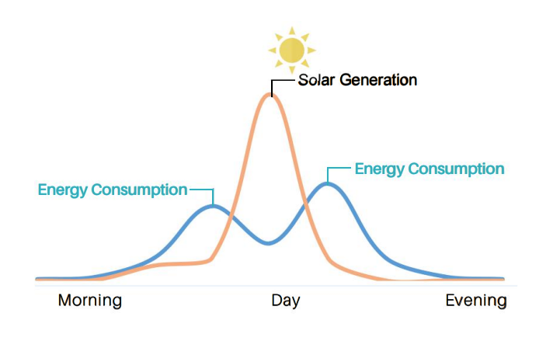
Users have a high demand for electricity in the morning and evening, but photovoltaic power generation is most abundant at noon, so there is a time imbalance between electricity supply and demand. The energy storage system balances the power supply and demand, stores the excess photovoltaic power generation in the day into the energy storage battery, and releases the electricity inside the battery to the home power supply when there is no photovoltaic power generation at night, so as to improve the self-use rate of photovoltaic power generation, so as to realize the independent operation of the grid.
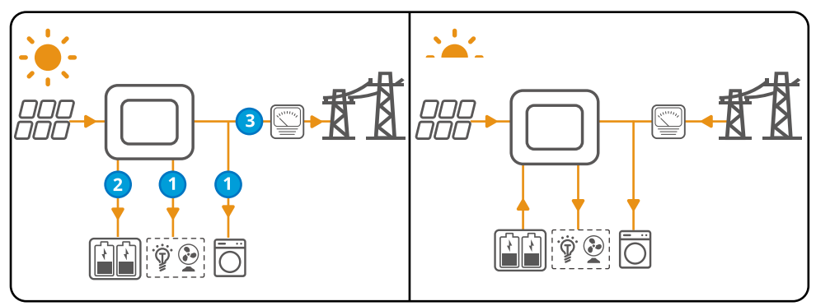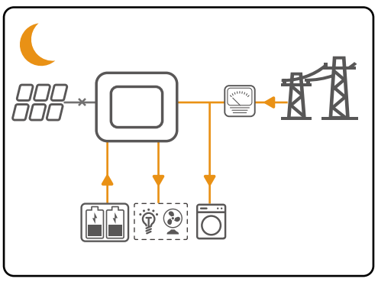

Economic model
It is mainly used to earn the difference between peak and valley electricity prices
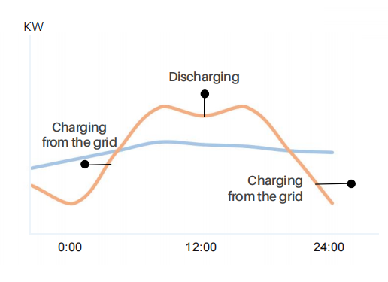
In the TOU area. Users store electricity at low times and use it at peak times to save users' electricity bills. For example, in the afternoon to evening in the summer, the power system load peaks, in this case, energy storage as much as possible to the home appliances power, avoid buying expensive electricity from the grid, but also reduce the load for the power system.
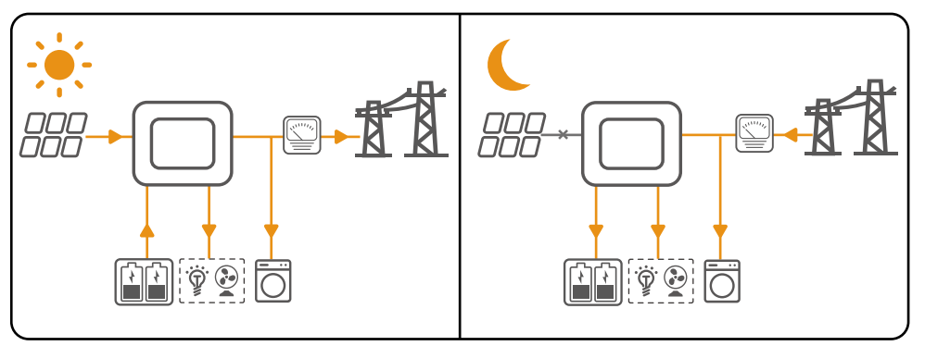

Backup mode
Mainly used for battery backup

In many areas where the power grid is unstable, energy storage as backup power is the strongest demand of users, and backup power is the just need that affects the normal life of the family, and has nothing to do with investment and income. Through the PV module, inverter power, battery capacity, load consumption (kW and kWh) and other reasonable ratio as possible, through the backup mode, users can provide you with safe and stable power when the grid is interrupted.

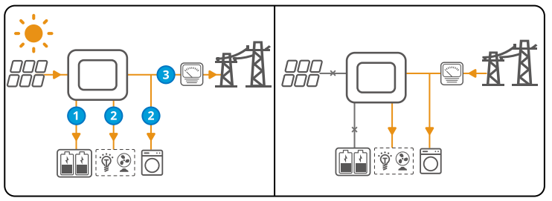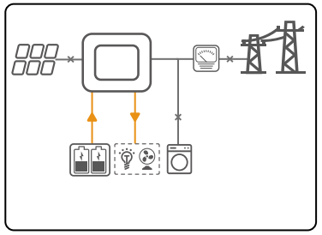

2 Battery Cell
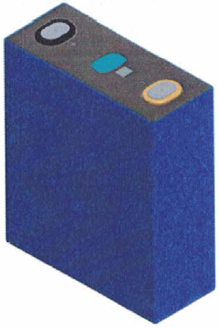
External View of Battery Cell
The battery cell adopts the standard 314Ah lithium iron phosphate (LFP) square aluminum shell cell produced by the mature automatic production line. The cell has high continuous power, long cycle life, long storage life and high safety.

Battery Data
S/N | Item | Data | Remark
1 | Cell Type | Lithium Iron Phosphate
2 | Cell Capacity | ≥314Ah | 25℃
3 | Nominal Voltage | 3.2V
4 | Nominal Energy | ≥1004.8Wh | 25℃
5 | Operating Voltage | 2.5V～3.65V  2.0V～3.65V | T > 0℃  T ≤ 0℃
6 | Nominal Charge/Discharge Rate | ≤0.5P
7 | Internal Resistance | 0.13±0.05mΩ | 25℃,50%SOC
8 | Number of Cycles | 7000 | 25℃ 0.5P/0.5P @70% Ret
9 | Operating Temperature | 0~60℃ charge  -20~60℃ discharge
10 | Storage Temperature | -30~60℃
11 | Dimension（W*H*T） | 174.26*204.44*71.65mm
12 | Weight | 5.49kg±0.5kg

3 Pack
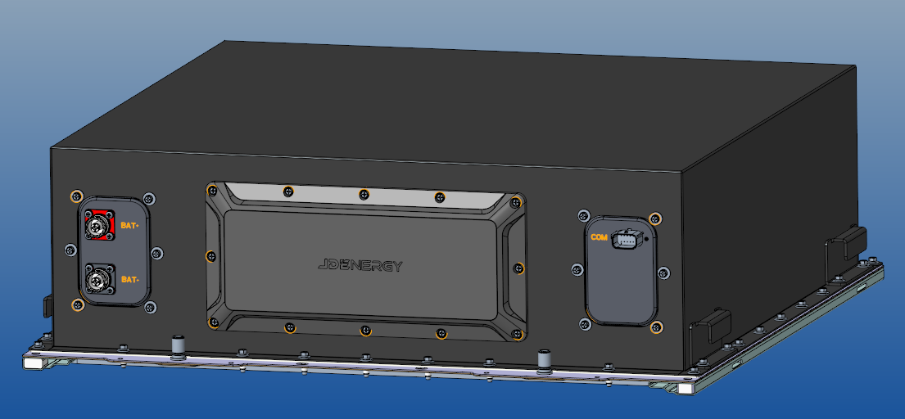
Battery Pack consists of battery unit, copper bar, collection cable harness, BMU, related electrical components, and structural components. The battery Pack configuration is 1P32S, 32 pieces 314Ah cells are connected in series, and the nominal voltage is 102.4V. The specific Data is shown as follows:
Battery Module Data
S/N | Item | Data | Remark
1 | Pack Configuration | 1P32S
2 | Nominal Voltage | DC 102.4V
3 | Nominal Energy | 32.15kWh | 25℃
4 | Operating Voltage | 89.6~115.2V
5 | Nominal Charge/Discharge Rate | ≤0.5P
6 | Operating Temperature | -35℃~55℃

4 RACK
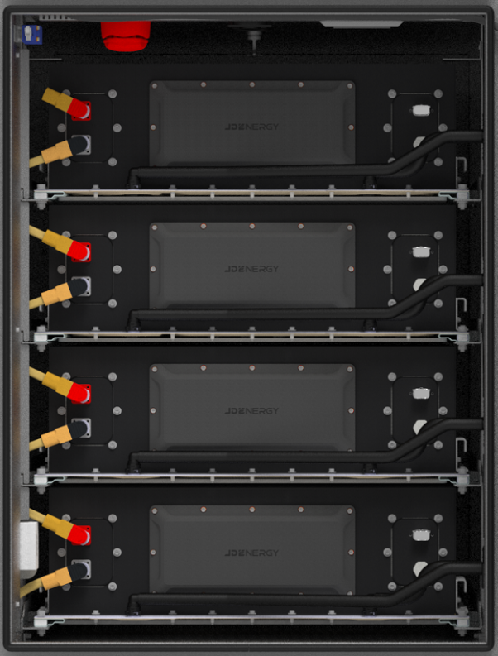
The battery Rack adopts a frame structure, and the battery Pack is fixed by bolts. A battery Rack consists of four battery Packs, which are connected in series and grouped in 1P128S mode. Battery Packs are arranged in the energy storage cabinet from top to bottom and connected through dedicated connectors on the front panel. The nominal voltage is 409.6V, the specific Data is shown in the following table:
Battery Rack Data
S/N | Item | Data | Remark
1 | Rack Configuration | 1P128S
2 | Nominal Voltage | DC 409.6V
3 | Nominal energy | 120Wh | 25℃
4 | Operating Voltage | 358.5~460.5V
5 | Nominal Charge/Discharge Rate | 0.5P
6 | Operating Temperature | -35℃~55℃

5 Battery Management System(BMS)
Battery Management System Data
S/N | Item | Parameters | Remark
1 | Current Acquisition Accuracy | ≤0.2A
2 | Single Voltage Acquisition Accuracy | Maximum Error≤5mV
3 | System Voltage Acquisition Accuracy | ≤±1%
4 | Temperature Detection Accuracy | Temperature sampling resolution≤1℃  Measurement error≤±1℃
5 | Single Voltage Acquisition Period | ≤50ms
6 | System Voltage Acquisition Period | ≤100ms
7 | Current Acquisition Period | ≤50ms
8 | Temperature Acquisition Cycle | ≤1s
9 | Balanced Mode | Passive Balancing
10 | Balancing Current | ≤100mA
11 | SOC Accuracy | The SOC estimation error of the battery system is less than 5%
12 | SOH Accuracy | The error in estimating the battery health SOH is less than 5%
13 | SOE Accuracy | The error of energy SOE estimation of the battery is less than 5%
14 | BMS Brand | JDEnergy

7 PCS
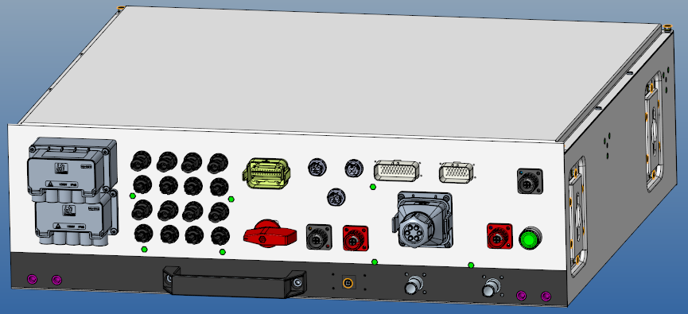
Topology Diagram of Power Conversion System
The Power Conversion System (PCS) can automatically track the maximum power point of the connected photovoltaic panels to maximize power generation. It can also accept the energy dispatching from the Energy Management System (EMS). When the system is unable to absorb the power from the photovoltaic panels, it will promptly limit the power output.
The PCS can charge and discharge the batteries according to the instructions from the Battery Management System (BMS) and the EMS, and ensure the reliable operation of the batteries based on comprehensive factors such as the State of Charge (SOC).
The PCS provides two alternating current (AC) ports. One is the grid-connected interface, and the other is the off-grid interface. The grid-connected interface can automatically track the frequency and phase of the power grid for grid-connected operation and provide supplementary power support for the system according to the EMS. The off-grid interface can supply a stable power source for customer loads.
Moreover, the PCS has a reliable power supply guarantee. When the PCS malfunctions, it can bypass the output in a timely manner. Or when the power grid fails, it can quickly enter the pure off-grid operation state to ensure the safety of power usage.
The PCS provides an external direct current (DC) power supply port that supports the connection of charging piles, realizing the solution of an integrated DC-coupled photovoltaic-storage-charging system.
Power Conversion System Data
Data | Specification | Remark
PV Input Data
Maximum Photovoltaic Input Power | 100kWp
Maximum DC Input Voltage | 1000V
Rated DC Input Voltage | 720V
Starting Voltage | 180V
MPPT Voltage Range | 150-900V
MPPTGroup | 4
Number of MPPT Input Groups per Route | 2
Maximum Input Current of Each MPPT | 40A
AC Input/Output Data (Grid side)
Rated Output Power | 50kW
Maximum Output Apparent Power | 55kVA
AC Rated Output Current | 72.2A
Power Factor | -0.8~0.8
Grid Voltage | 3L/N/PE 230/400V
Grid Frequency | 50Hz
Rated Power Harmonics | ＜3%
Maximum Input Current of the Power Grid | 144.4A
AC Output Data (Off-grid side)
Rated Output Power | 50kW
Off-grid Peak Power/long time | 55kVA
Off-grid Peak Power /1 min | 60kVA
Fastest on/off Grid Switching Time | ＜10ms
Rated Output Voltage | 3L/N/PE 400V
Voltage Frequency | 50Hz
Rated Output Current | 72.2A
Peak Output Current | 79.4A
Total Voltage Distortion Rate | ＜2%
Hybrid Converter System Data
Operating Temperature Range | -35~60℃(>45℃ derate)
Cooling Mode | Liquid Cooling
Humidity | 0~95%
Protection Level | IP65
Altitude(m) | 4000
Protection Function
Island Protection | Comply
AC Output Over Current/Short Circuit Protection | Comply
Integrated DC Switch | PV DC switch is available
DC Reverse Protection | Available (PV and Battery)
Surge Protection | DC secondary/AC secondary

8 Liquid Cooling System
At present, the thermal management of energy storage industry includes air-cooled heat dissipation and liquid-cooled heat dissipation, etc., and with the improvement of battery energy density and unit capacity, more heat generate, which gives more requirements on the temperature management of energy storage system. At present, more and more high-capacity battery cells have been put into market, and conventional air cooling is difficult to ensure the long-term operation of high-capacity battery cells. Therefore, liquid cooling technology is the trend of energy storage thermal management development. To ensure stable operation throughout the entire lifecycle of the system, appropriate thermal management strategies and selection of liquid cooling units are crucial.
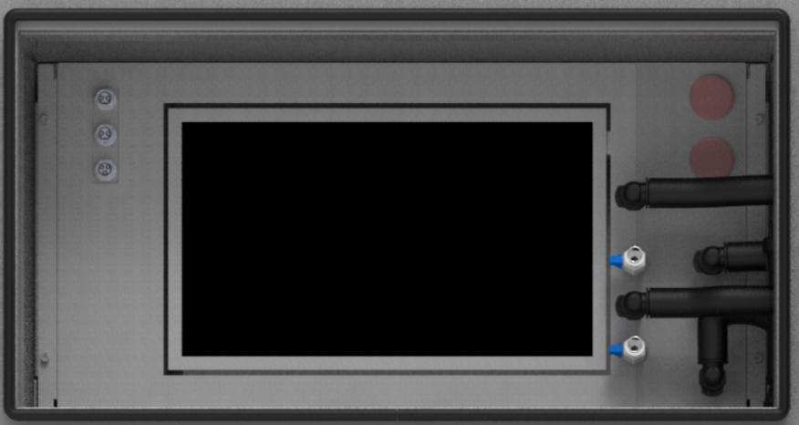
External View of Liquid Cooling Chiller
The battery thermal management system of the cabinet products of JDEnergy adopts the liquid cooling solution, that each cabinet is equipped with an independent thermal management system, which uses a chiller and uses ethylene glycol solution as the cooling medium.
An advanced and efficient battery thermal management system was developed by means of careful design, multi-dimensional simulation and full-condition testing. Each Pack is equipped with an independent water-cooled pipe and corresponding inlet and outlet. The coolant in the chiller enters the water-cooled pipe in each Pack in parallel under the drive of the water pump, and absorbs the dissipated heat generated inside the Pack through heat conduction and convection. After heat absorption, the coolant collects and flows into the chiller. These Packs are electrically connected in series and work in exactly the same condition. The parallel flow sharing liquid cooling environment control scheme is adopted to further ensure that the battery is highly consistent in the operating and storage environment. In the whole life cycle management of the system, it provides a good operating environment for the battery, so that the energy block has a longer life and is more efficient.
The battery thermal management system can customize simulated working conditions according to the project historical database and project site conditions, and then combine the thermal related operation status of the project gerontological data simulation system throughout the life cycle to finally determine the thermal management strategy and supplemented by thermal simulation verification.
After the project is put into operation, the system will upload the operation data to the EMS, and through the processing and analysis of the operation data, the thermal management strategy can be optimized and iterated.
The liquid medium has high heat transfer coefficient, large specific heat capacity and fast cooling speed, which has significant effect on reducing battery Pack temperature and providing the consistency of battery cluster temperature field. The thermal management system can control the temperature of the cell within 35℃, and the temperature difference of the cell within the same battery cluster does not exceed 2℃.
In addition, in this system, the Power Conversion System (PCS) also adopts the liquid-cooling heat dissipation method and shares a water chiller with the battery PACK. The liquid-cooling method can make the temperature of the internal components of the PCS lower and greatly improve its reliability.

9 Fire Suppression System
1 Fire protection system scheme
eBlock-100C product fire protection solutions are cluster level fire aerosol, cluster level water fire protection, cluster level composite detector.
The energy storage fire linkage system can be divided into fire detection system, fire extinguishing system and emergency water spray. When a fire occurs, the fire extinguishing system quickly intervenes to detect, alarm and extinguish the fire. If the fire spreads or refires occur, and the fire extinguishing system cannot control the fire, emergency water spray can be connected for emergency disposal to prevent deflagration, fire and other serious consequences.
2 Fire protection system component
（1）Cluster aerosol selection
Reference to European standard EN15276 to calculate the design dosage of aerosol fire suppression:
V=818×1005×1049mm=0.86m³
W=0.86m³×97g/m³×1=83.42g
The current selected aerosol size is 100g.
Product selection: Electric start + feedback, meet the CE certification standard (EN15276)
（2）Thermal runaway alarm system selection
According to the requirements of NFPA855 specification, fire alarm and combustible gas detector should be installed in the cabinet, and composite detectors should be selected to detect combustible gas with smoke and temperature, meet the requirements of CE certification, occupy less internal space and have large cost advantages.
Dimension | 7 0mm × 114.4mm × 24mm
Weight | 200g
Working temperature: | -40℃～85℃
Working humidity: | 5％～95％RH ，non-condensing
Alarm current: | 15 ～32 VDC
Voltage range: | 15 ～32 VDC
Operating current: | ≤10 m A
Smoke alarm concentration: | ＞0.3dB/m
Temperature alarm value: | 69 ℃
Carbon monoxide alarm concentration: | 800 PPM
（3）Emergency water spray
The battery compartment is equipped with a water fire sprinkler head. When a fire occurs, the fire hose can be connected to the standard quick connector to supply water to the battery compartment.
The cabinet side reserve water fire interface DN32 pipe, the main pipe should be galvanized steel pipe, through threaded connection, the end nozzle in the warehouse using K115 sprinkler, the temperature is 93℃, the joint using DN20, meet the European standard certification requirements.
According to the standard requirements, the working pressure of the sprinkler head at the most unfavorable point of the automatic spray extinguishing system is 0.05MPa, according to the formula
It is calculated that the flow rate of a single sprinkler is 81.305L/min, and the area of the storage tank is 1.038m*0.915m=0.949m2. The spraying intensity is 452.8/3.76=85.67L/ (min•m2), which meets the requirements of severe danger level
Pool water calculation: V need =7.5×2×60×60=54000L=54m3
No | Item | Requirement | Remark
1 | System type | Wet system
2 | Operating area (m²) | 0.945
3 | Sprinkler type | Closed sprinkler | Starting temperature 93℃
4 | Spray intensity  L/min·m | 85.67
6 | Pressure required for water interface | 0.2Mpa/20m
7 | Fire duration | 2h | Fire hydrant system
8 | Joint form | DN32internal thread
9 | Pool water demand | 54m³ | Calculation reference:  3.6×7.5L/S×2h
（4）Exhaust system
According to NFPA68 design requirements, the exhaust system must use explosion-proof fans; The exhaust volume of the fan per minute is not less than the net volume; When using electric actuator, explosion-proof actuator should be used.
The exhaust system uses the exhaust assembly (PF-80A), the combustible gas detector three-in-one detector, and the carbon monoxide data is read through RS485.
3System linkage
When a fire alarm is triggered, disconnect the DC relay, AC relay disconnect, and PV circuit breaker, and store the battery temperature, voltage, and fire monitoring data 10 minutes before and after the alarm to facilitate analysis of the cause of thermal runaway. At the same time, the electric starting aerosol is sprayed and the starting signal is fed back to the system.

Abbreviations
JDEnergy | JDEnergy Co., Ltd
BESS | Battery Energy Storage System
BMS | Battery Management System
BMU | Battery Management Unit
BCS | Block Control System
LCS | Liquid Cooling System
PDB | Power Distribution Box
EMS | Energy Management System
ETH | Ethernet Module
CAN | Controller Area Network
DOD | Depth of Discharge
FSS | Fire Suppression System
PCS | Power Conversion System
SOC | State of Charge
SOE | State of Energy
SOP | State of Power
SOH | State of Health

